Eyeconic-Sprays Shop Management System

Use-Case Specification: Add Sprays

Version <1.0>

Revision History

|  |  |  |  |
| --- | --- | --- | --- |
| **Date** | **Version** | **Description** | **Author** |
| <04/11/2019> | <1.0> | creating use case | Nguyễn Tuấn Anh |
|  |  |  |  |

Table of Contents

1. Add Sprays 4

1.1 Brief Description 4

2. Flow of Events 4

2.1 Basic Flow 4

2.2 Exception 4

2.2.1 Add Sprays 4

2.2.2 Fill in the Sprays information 5

3. Special Requirements 5

4. Preconditions 5

4.1 Admin must be logged in 5

5. Postconditions 5

6. Extension Points 5

Add Sprays

# Add Sprays

## Brief Description

This use case defines the step of create/add a new Sprays to the database.

Sprays are added by the admin.

# Flow of Events

## Basic Flow

The system administration clicks a button to add a new item. The administrator fills the information of the new Sprays. The system displays the new Sprays and logs the change.

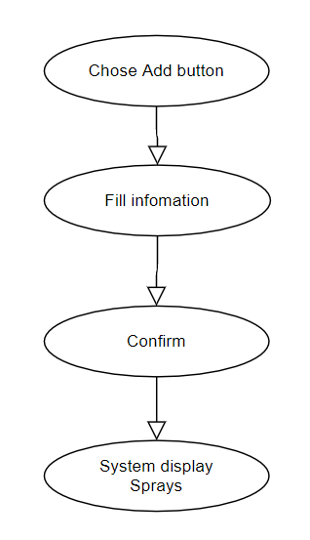

***Basic flow of Adding Sprays***

Step 1: Click the add buttons

The modal view shows up

Step 2: Fill in the Sprays information, name, type, …

Step 3: Confirming adding the Sprays by clicking the “Save” button.

Step 4: Successful added Sprays is displayed to the screen.

## Exception

### Add Sprays

The add button cannot be clicked or isn’t appeared on the screen

### Fill in the Sprays information

Invalid information.

Must fill out all the information in the form.

2.2.3 Confirming adding the Sprays

The “Save” button is clicked but the new Sprays are not added to the database.

This new Sprays are existed in the database.

2.2.4 System displays added Sprays

The added Sprays is not display correctly

# Special Requirements

No Special Requirements

# Preconditions

* User must already login as the administrator of the website
* The added Sprays had not existed in the database before.

# Postconditions

Sprays are created, shown on the screen can be purchased by customers.

# Extension Points

Administrator check the website and the system to ensure that the Sprays is added to the database and display on the screen.